Lov na blago!
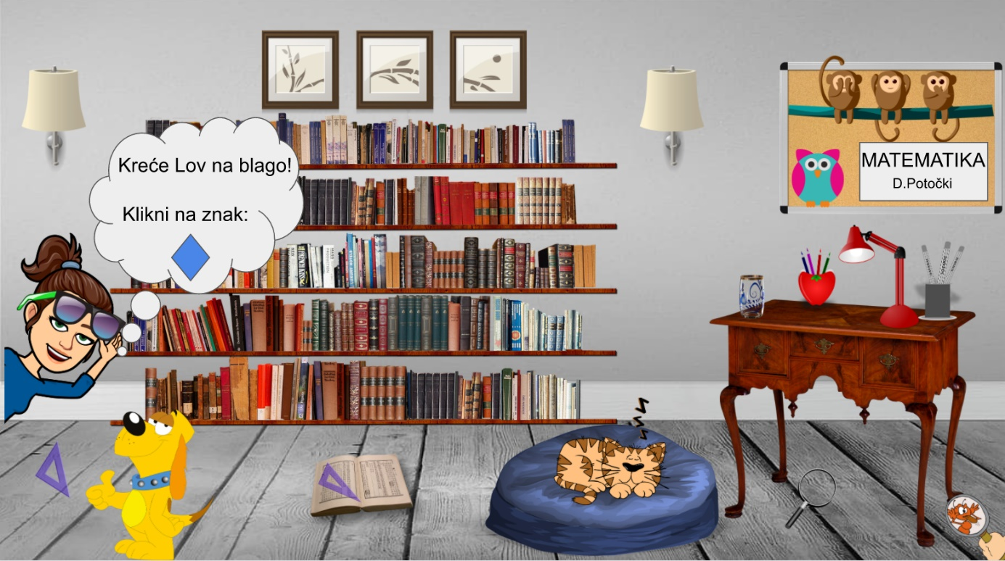

https://docs.google.com/presentation/d/1_t-imwMrzfzyBsL_y89QVoBb0ZURrnArS9oBHTBw4ZU/present#slide=id.p

Autorica: Dražena Potočki, OŠ Novska, Novska

